Maths & Number Apps

Fractions, Numbers to 100, + - x /
Splash Maths

Shape, Position, Movement
Bee Bot

Symmetry
Maths Champions

Fractions
Fraction Lite Pizza Fractions 1
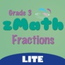 zMath Grade 3 Fractions

Times Tables Practice
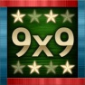 Multiplication+ 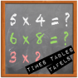 Times Tables Trainer
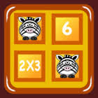 Match Math Tables 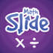 Maths Slide: multiplication & division

Add Subtract Multiply Divide
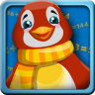 Penguin Math 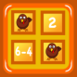 Match Math
Mushroom Maths 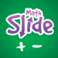 Maths Slide: addition & subtraction 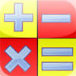 Maths Trainer 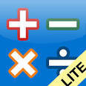 AB Math Lite

Number Bonds
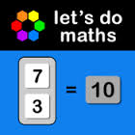 Number bonds to 10 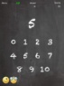 Number Bonds Chalkboard
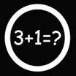 CalcHit
Multiplication & Division– Understanding
Lumio Farm Factor 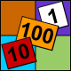 Dare to Share Fairly

Place Value
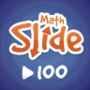 Maths Slide: tens & ones 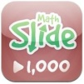 Maths Slide: hundreds, tens & ones
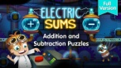 Lumio Electric Sums Addition and Subtraction
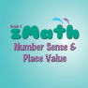 zMath Grade 3 Number Sense and Place Value
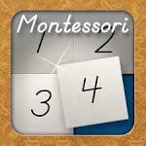 Montessori Number Board

