

### **Strathesk Primary School**

**Newsletter – October 2017**

***Dear Parents/Carers***

*Autumn has come along quickly and we are now enjoying windy days – please ensure children are well wrapped up for the coming seasonal change. School is busy as usual with everyone settled and working hard. Everyone enjoyed Meet the Teacher and this event really helped to get the year off to a positive start. I have been delighted to notice children in school being so well mannered and polite – our establishment phase has really worked this year in helping children learn school and class rules and develop strong, positive relationships. Keep up the good work everyone!*

*Ms Donaldson*

**

***Meet The Teacher***

*Many thanks to all parents and carers who turned up for our Meet the Teacher session in September. It was an excellent turnout and we received so many lovely comments about our school and our fabulous team of teachers. Needless to say we will be continuing this session each year.*

**

***Sporting Achievements***

*Well done to our P 6&7cross country runners – Olivia, Abbie and Struan all received medals. Hannah in P7 continues to impress with her Karate successes – receiving 2 medals last week. Coming soon – rugby, hockey and basketball! We continue to follow ex-pupil Jasmine Black and her Trampoline career. Last weekend she competed at the Scottish National Trampoline Championships and is once again Scottish Champion for her age group and level! Great news!*

***I-Bike***

*This session we are lucky enough to have special input from Gordon Burt from the Sustrans Bike Movement. Our very own Mr Howie is working with Gordon to develop a whole school approach to cycling – embracing and developing the positive impact of biking across the school curriculum. Mr Howie will be running cycling groups, teaching about safe cycling and other exciting bike-related topics. Stay tuned for more news!*

**

***Staffing***

*Congratulations to Principal Teachers Miss Reynolds and Miss Henderson who will be taking over from Mrs Smith as part time Acting Depute Headteachers. We will be recruiting for another class teacher to allow for increased management time. We will also be recruiting for a Principal Teacher. All posts will be until March 2018 in the first instance.*

**

***Parent Helpers***

*During ‘Meet the Teacher’ we had lots of parents who signed up to be helpers – please don’t forget to speak to your class teacher about opportunities – if you don’t call us we will call you! It’s great to see such successful partnership working.*

***Parent Partnership***

*Strathesk Parent Partnership are trying hard to increase membership. They could benefit from support from parents of children at all stages of school, including nursery. Parents can attend meetings as regularly as they choose, help out at events and have a voice in the life and work of Strathesk. Give as much or as little of your time as works for you! Representatives from the Parent Partnership will be at our Parent Consultations in December – do speak with them to find out how you could be involved. You can also have a look on the Parent Partnership Facebook page. *

***Penicuik Learners!***

*Four Primary 5 pupils have been specially selected to represent Strathesk Primary School as part of the Penicuik Cluster Learning Committee. Pupils from Cornbank, Sacred Heart, Cuiken Primary Schools and S3 pupils from Penicuik High School will be coming together to discuss what makes a great learner! Well done to Ryan, Carly, Aidan and Kaya for their super applications for this prestigious post!*

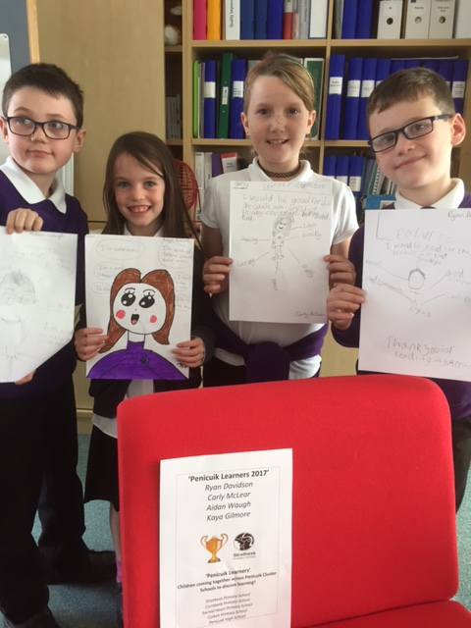

***Thank you from Mrs Smith***

*I would just like to thank all pupils and parents for their generosity and kindness on my last day at Strathesk. I wish everyone the best of luck for the future and look forward to hearing about lots of positive things happening at Strathesk. Best wishes, Sharon Smith*

**Diary Dates**

|  |  |
| --- | --- |
| **Date** | **Event** |
| **Friday 6th October** | P6 & 7 Rugby Festival |
| **Wednesday 11th October** | 6pm-7.30pm P4-7 Disco |
| **Monday 9th October** | House Treat |
| **Monday 9th October** | Penicuik Learners Meeting 1 Cornbank Primary School |
| **Wednesday 11th October** | Science Festival - Science & Music Workshops for P5&6 |
|  |  |
| **Thursday 12th October** | ‘Lepra’ Thank you – whole school workout sessions |
| **Monday 16th – Friday 20th October** | October holiday  Pupils resume Monday 23rd October |
| **Tuesday 24th October** | Hockey Festival |
| **Wednesday 25th October – Wednesday 29th November** | Skiing (Block 1) |
| **Monday 30th October** | Parent Partnership 6pm |
| **Tuesday 31st October** | Harvest Festival – donations welcome |
| **Monday 6th November** | Equalities week |
| **Monday 13th November** | Anti-bullying week |
| **Thursday 16th November**  **8.50-10.30am** | Sharing Learning – all classes P1-7 |
| **Tuesday 21st November** | New primary 1 children enrol |
| **Thursday 23rd November** | P5 to Dynamic Earth |
| **Thursday 7th December 4-7pm**  **Friday 8th December 1-4pm** | Parent Consultations  (Book Fair in school this week) |
| **Tuesday 12th December**  **Wednesday 13th December** | Cinema Trip P4-7  Cinema Trip P1-3 |
| **Thursday 14th December** | School Christmas lunch |
| **Friday 15th December 1-3pm** | Christmas Fair |
| **Monday 18th December** | House treat |
| **Wednesday 6th December -Wednesday 14th March** | P4a Swimming  *(P4b will swim Wed 21 March – Wed 27 June)* |
| **Wednesday 20th December** | Nativity AM & PM performances (times tbc) |
| **Friday 22nd December**  **Tuesday 9th January** | Term ends  Resume |

**Diary Dates**

***Look out for date changes***



***Purpleman – An Odyssey!***

*What a success this adventure has been! If you have been helping with homework or following Twitter you will know that each week the children have had a new mission to complete to help Purpleman save Beelax the peacful Traxian being from the powerful Zalesh! Classes have been learning so much along the way – about life, friendship, fairness and equality, amongst other things! What a journey!*

**

***j0205582Twitter***

*Just a reminder that we have a school Twitter account. It is the best way for us to communicate current information to the widest audience. Please sign up on @StratheskPS*



***‘Learning together benefits all’***

***Money – Lunches and Trips***



*Please remember to send your child with lunch*

*money which is now* ***£1.90*** *per day – and* ***additional***

*money if they also require tuck which is 20p.Please ensure your child has the exact separate change for both lunch and tuck. Please also make sure your child knows exactly what their money is for! Any money for school trips should come with your child in an envelope marked with their name and amount and* ***NOT*** *directly to the school office. Thank you!*

***Additional Reminder!***

*Please make every effort to arrive at school on time and enter through the correct door – we have had an increase in latecomers which is not only disruptive to the office staff but also impacts on the beginning of the learning day for the children. Thank you.*