

Strathesk Primary School 

Standards and Quality Report 2016-2017
&
Improvement Plan 2017-2018
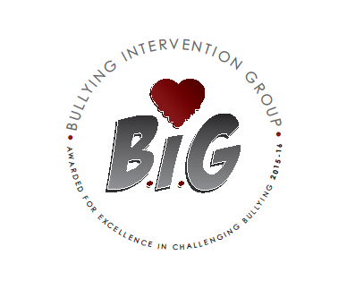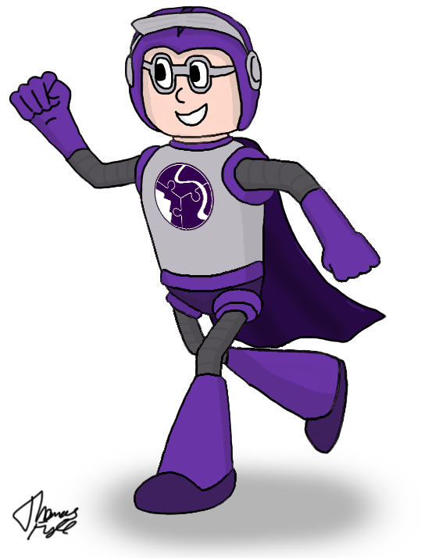

‘Learning together benefits all’

Contents – Standards and Quality Report

1. Our School Vision, Values and Aims

2. How our Vision, Values and Aims were developed and how our Stakeholders were consulted.

3. Context of the School

4. Review of Progress for Session 2016-17

5. What is Our Capacity for Continuous Improvement?

6. Highlights from Session 2016-17

1. Our School Vision, Values and Aims

‘Learning together benefits all’

‘A school where every child is provided with learning opportunities of the highest quality which nurture their ambitions and where pupils are encouraged to achieve their full potential academically, physically, socially and personally.’

Our Values
- The importance of life-long learning skills and attitudes in a changing society
- A partnership between pupils, staff, parents and the wider community.
- Achievement for all
- Respect and responsibility
- Our health and well being
- Our environment and community
- Equality and Citizenship
- Creativity, independence and choice
- Celebrating success

Our School Aims

Key Performance Outcomes
To ensure that all pupils are able to realise their potential through the promotion and recognition of achievement and excellence.
Impact on Learners
To strengthen the supportive partnership within the school with parents and the wider community.
Impact on Staff
Staff are committed to, and actively involved in, the life of the school.
Life in the Community
To engage successfully with the local community

2. How our vision, values and aims were developed and how our stakeholders were consulted.

In evaluating key areas of the service we deliver, we have drawn on a range of evidence including:

- Parent voice – data and opinion sought throughout the year, The Parent Partnership
- Pupil Voice (Visible Learning Feedback groups and data gathering methods, Pupil Council)
- Teachers’ Voice (Relational Trust, Self-Evaluation, robust collegiate activities and meetings, high level of consultation and participation)
- Attainment data reflecting pupil performance in ongoing assessments and areas of need
- A planned programme of observations of classroom experiences
- Monitoring of pupil work, teacher planning and course materials
- Ongoing review of service through self-evaluation
- Responsive approach to child, family and community needs
Our mission statement was developed collegiately as were the school aims and vision. However, over the past three years and with changing circumstances and opportunities, it may be worth revisiting the vision, values and aims in relation to:
- Support for children and families
- Parents as partners
- Interrupting the cycle of poverty

3. Context of the School - Include some or all of the following:

Local contextual issues, involvement in local or national initiatives, factors affecting progress and self evaluation outcomes – maximum 2 pages

Strathesk Primary School was officially opened on 20 June 2008 as a Private Partnership Programme. The School is the result of a merger between the former Ladywood and Eastfield Primaries and Strathesk Nursery.
The school supports transition arrangements for both Beeslack Community High School and Penicuik High School.

During session 2016/17 there were 334 children in 13 classes within the Primary School and 100 children in the Nursery (50 am and 50 pm).

Strathesk Primary School has had a challenging year, with periods of management staff absence and continued difficulties in obtaining supply staff. Although the majority parent group are supportive and happy, certain instances of parental mistrust have challenged staff morale and have impacted on the positive reputation of the school in the wider community and this requires reflection and action in session 17-18. That said, school has been running smoothly and calmly, with the entire staff team working extremely well together, adopting solution focused approaches. Learning and teaching has remained of consistent high quality and children and classes have experienced many successes.

Visiting managers have commented that Strathesk is a calm and relaxed learning environment with children obviously engaged in learning, happy to be in school and extremely polite.

Strathesk Primary School has been awarded £105,000 from the Scottish Government to support pupil equity in session 2017-18.

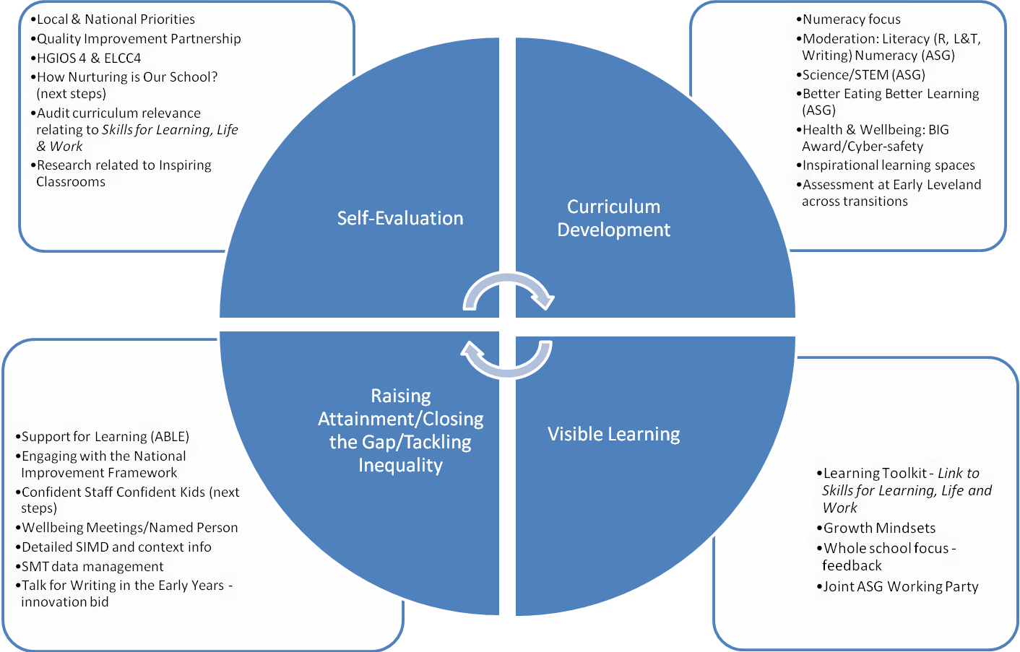

4. Review of progress for Session 2016-17

 | School priority 1: Improved attainment in numeracy and maths
 | NIF Priority  Improvement in attainment, particularly in literacy and numeracy  NIF Driver  Assessment of children’s progress |  | HGIOS 4 Quality Indicator(s)  Raising attainment and achievement
Local Priority

ASG and in-school developments to support the learning and teaching of numeracy
Progress and Impact:
- Learning Journeys in full use in upper school and being developed in lower stages.
- Learning Journeys have been moderated (at planning stage and with peers) and good practice shared with new staff.
- New MUMP assessments moderated against old ones and new benchmarks – feedback passed on.
- Pace and challenge supported by tracking systems and valuable data-based progress meetings.
- Majority of staff have attended SEAL training and resources are completed and in use in school. Staff are using new MUMP planners are more familiar with the language of SEAL.
- Resources ordered for each stage to support Basic Maths Facts from 1st level.
- Bank of problem solving plans being created at each stage.
- Revision sheets used regularly.
Next Steps: As per school numeracy plan 2017-18
- Address staff awareness of GL tests – style and example Q’s, not content
- Embed Basic Maths Facts programme to ensure revision of key facts and develop quick recall
- Target intervention at key stages (PT management time to address needs)
School Priority: To continue as school priority 2017-18

School priority 2: Improved health and wellbeing for all service users
 | NIF Priority  Improvement in children and young people’s HWB  NIF Driver  Assessment of children’s progress | HGIOS 4 Quality Indicator(s)  Ensuring wellbeing, equality and inclusion  Local Priority  Whole school approach to robust Health and Wellbeing development for all
Progress and Impact:
- Achievement of GOLD Award (Sport Scotland) – improved community links.
- Cross stage learning continues to be successful in building positive relationships.
- The BIG Award – systems in place and effective.
- Peer mediation in place.
- Fun Ones – supporting improved play ground experiences.
- House System continues to be popular.
- Pupil Council in place.
- Cool in School delivered systematically.
- Robust establishment phase.
- Induction policies for new staff.
- Successful staff running club.

Next Steps: As per school Health and Wellbeing priority 2017-18
- Review systems for sharing BIG award information with parents.
- Review elements of BIG award e.g. mediation/fun ones – how effective are these systems?

School priority: To continue as school priority 2017-18
School priority 3: Whole school engagement with Visible Learning agenda

NIF Principle  Improving classroom practice and placing the learner at the centre  NIF Driver  School improvement |  |  |  | HGIOS 4 Quality Indicator(s)  Learning, teaching and assessment  Local Priority  Development of whole school approach to Visible Learning
Progress and Impact:
- Educational psychologist input at professional dialogue – to support momentum
- Terminology from Strathesk Learning Toolkit and Growth Mindset work embedded in everyday dialogue.
- Learning journeys used in maths and numeracy.
- Achievement certificates refer to effort and are based on the learning toolkit terminology.
- Visible learning staff project data shared at transition of classes.
- Inspirational learning Spaces – direct link to learning environment and process.

Next Steps:
- Further information sharing with parents.
- Refine school focus.

School priority: To continue as school priority 2017-18

School priority 4: Development of the Curriculum

NIF Priority  Improvement in attainment (Lit/Num)  NIF Driver  Assessment of children’s progress | HGIOS 4 Quality Indicator(s)  Leadership of learning  Learning, teaching and assessment  Curriculum  Raising attainment and achievement  Local Priority  Literacy/Numeracy and cross – curricular approaches to support the development of the curriculum
Progress and Impact:
- Effective moderation in literacy and numeracy. Collegiate time devoted to peer moderation, planning, working with stage and cross stage partners – improved professional dialogue. Discussions around achievement of a level, tracking. Learning journeys in use, writing rubrics continue to be effective, ASG moderation of listening and talking well received.
- Robust work in Science through staff training and development – improved classroom experiences.
- Inspirational learning spaces – adaptations to learning environment.
- Talk for Writing in the Early Years (HMI Innovation Bid) – measured improvement in child storytelling skills, staff up-skilled in development of early literacy.
- 1+2 Agenda – staff attended Erasmus and returned with increased confidence – excellent sharing session for staff with practical tips and resources.

Next Steps: As per Curriculum/Raising attainment priority for 2017-18
- Continued moderation systems
- PT to develop in-school moderation
- Further develop role of Numeracy Coordinator
- Develop Talk for Writing – adapt assessment requirements and plan for nursery transition around the project. Develop P1-2 curriculum based on longer day and balance of curriculum needs as well as play agenda.
- Continued delivery of French – begin Spanish training
School priority: To continue as school priority 2017-18
Attainment Data
In order to assess attainment we use a range of assessment procedures including data from standardised assessments. Their findings are:

PIPs results for P1 Cohort 2016-17
Analysis of the Value Added of our P1 2016-17 cohort
Value Added
Maths | Reading
(Average)  19/52 children (37.2%) | (Average)  20/51 children (39.2%)
(--)  8/51 children sitting in bottom 10% = 15.6% | (--)  5/51 children sitting in bottom 10% = 9.8%
(-)  11/51 children sitting in bottom 15% = 21.5% | (-)  7/51 children sitting in bottom 15% = 13.7%
(+)  8/51 children sitting in top 15% = 15.6% | (+)  5/51 children sitting in top 10% = 9.8%
(++)  1/51 children sitting in top 10% = 1.9% | (++)  9/51 children sitting in top 15% = 17.6%

Annual Progress Table of the Mean Standardised Assessment Scores of 2016-17’s P4 and P7 classes:
 | P3 2015-16 | P4 2016-17
NGRT | 91.43 | 102.55
 | P3 2015-16 | P4 2016-17
PTM | 104.55 | 102.10

 | P6 2015-16 | P7 2016-17
NGRT | 99.76 | 106.69
 | P6 2015-16 | P7 2016-17
PTM | 96.7 | 98.1

Pupils’ Achievement by June 2017 in Curriculum for Excellence (CfE) Levels
Early Years Level: generally by the end of P1
First Level: generally by the end of P4
Second Level: generally by the end of P7
Third Level: generally by the end of S3

Comparison of result 2015/16 – 2016/17
Percentages of pupils achieving CfE Levels: | Talking and Listening |  | Writing |  | Reading |  | Numeracy |  | Maths
 | 2015/16 | 2016/17 | 2015/16 | 2016/17 | 2015/16 | 2016/17 | 2015/16 | 2016/17 | 2015/16 | 2016/17
P1 pupils achieved early level secure or working within first level | 79% | 59% | 79% | 39% | 68% | 47% | 72% | 41% | 83% | 47%
P4 pupils achieved first level or working within second level | 84% | 57% | 57% | 14% | 70% | 86% | 65% | 80% | 65% | 37%
P7 pupils achieved second level or working within third level | 26% | 26% | 13% | 13% | 13% | 79% | 23% | 49% | 23% | 38%

Predictions for 2017-18
Percentages of pupils achieving CfE Levels: | Talking and listening | Writing | Reading | Numeracy | Maths
P1 – achieved early level or working within first level | 76% | 76% | 76% | 85%
P4 –achieved first level or working within second | 68% | 32% | 53% | 47%
P7 – achieved second level or working within third | 50% | 22% | 52% | 52% | 38%
5. What is Our Capacity for Continuous Improvement?

Quality Indicator | School Self Evaluation | Authority Inspections / Theme visits | HMIe Inspection Grades
1.1 Self Evaluation for self improvement | HGIOS4  Themed visits | QI 1.1 Evaluation Visit October 2017 | Good
1.3 Leadership of Change | HGIOS4  ASG planning | QI 1.1 Evaluation Visit October 2017 | Good
2.3 Learning, teaching and assessment | HGIOS4  Transforming learning  Primary Curriculum Action Plan  Toolkit – challenge questions  Moderation timetable  Monitoring – class visits and walk throughs | tbc | Good
3. Ensuring well being equity and inclusion | HGIOS4  PEF Measures  Delivering Equity and Excellence Document  How Equitable is our School? (Avis Glaze audit materials) | tbc | Very good
3.2 Raising attainment and achievement | HGIOS4  Formal Assessment  Robust moderation and tracking  Primary Curriculum Action Plan | tbc | Good
2.2 Curriculum – Theme: Learner pathways | HGIOS4  Engagement with benchmarks (numeracy) | tbc | Good
2.7 Partnerships – Theme- Impact on learners | Engaging Parent and Families Toolkit – Involving all parents | tbc | Satisfactory

6. Highlights from Session 2016-17
The school provides quality experiences for our learners to develop under the four contexts of CfE, for example:
Key Successes
‘Ethos and life of the school as a community’ and ‘Opportunities for Personal Achievement’:
- Pupil participation, responsibility and voice – Pupil Council, class assemblies, Fun Ones, P1 buddies, Sports Committee, Peer Mediators, P7 prefects, P5 Recycling Ambassadors
- BIG Award Accreditation awarded in Dec 2015 – first school in Scotland
- P7 Penicuik High School Transition Camp in May to Netherurd House, P6 Residential camp in May to Benmore Outdoors Centre
- Strathesk school choir performance for parents, including the release of our Equalities track, written by Mr Armstrong and performed by the choir
- Achievement of Sport Scotland Gold Award. Increased after school club opportunities, whole school celebrating (Rugby World Cup, Olympics cross stage learning). High participation in cross school tournaments. 2 hours PE delivered to every child across the school. Uptake of Daily Mile in most classes
- Establishment phase implemented at start of school year to ensure teachers and pupils establish expectations, school ethos and pupil ‘buy in’
- Supporting S4, S5 and S6 pupils in widening their own experiences through volunteering
- Wider achievement of pupils celebrated weekly at Song Practice and Assemblies. Children given certificates for personal academic achievements and wider achievements. End of year certificates changed to reflect effort and progress, rather than top pupil
- Twitter and School website used to share school, community, learning and achievement information with parents
- Regular Parent Partnership meetings, working on Christmas Fair, school discos and school prom
- Highly attended parent consultations, choir and Nativity performances
- Revamping of School Sports Day – working with parents to improve experience for competitors and parent viewers
- Continuation of House System: cross staged learning opportunities, weekly, termly and yearly winners
- P7 Fundraising day
- P7 pupils took part in the Rotary Quiz
- Excellent transitions Nursery to P1 and P7 to High School
- Some upper school children participating in Instrument tuition: 3 learning violin; 4 learning woodwind instruments and, 3 learning brass instruments
- Support the needs of specific children with BST, Play Therapists, Ed Psych and other agencies.

‘Curriculum areas and subject’ and ‘Interdisciplinary Learning’
- P7 pupils take part in Inspiring Classrooms initiative – designing and adapting their learning environment to facilitate improved learning and teaching
- Primary 1 and 2 take part in Innovation Bid – Talk for Writing in the Early Years – measured improvement in storytelling skills and engagement tin literacy
- After school clubs offered by teachers: volleyball, art, choir
- Enhanced experiences in Science as part of ASG involvement with STEM
- P7 use forensic skills in The Mayberry Mystery – science based thematic learning
- Risk Factory visit for our P7 pupils linking all their personal safety agenda to real life scenarios
- Inter school walk, to highlight the benefits of walking to school
- Skiing offered to P5-P7 pupils
- Swimming lessons for P4 pupils
- P6 and P7 children gained the John Muir Award
- P6 participation in Euroquiz
- Introduction of French throughout the whole school. Pupils enjoyed working with Lorry, the French Modern Languages Assistant
- Whole school learning about recycling waste – introduction of P5 Recycling Ambassadors to support recycling in the dining hall
- Introduction of new Health and Wellbeing Programme to support the school needs, with strong links to IDLs. Cool in School terminology used throughout the school
- Various class trips across the Nursery and the whole school to support the learning in class.

How well does the school support children to develop and learn?
Key Successes
- Effective transition programmes in place between the transitions of nursery, P1 and P7 into high school and home into nursery – enhanced nursery – P1 transition
- Reflective practice taking place in class, incorporating personalisation and choice, including our learners in establishing their next steps
- Play therapy for individual children and Behaviour Support Teacher worked with various children to support their needs
- Continuation of Learning Journeys within maths and numeracy across middle and upper stages
- Seasons for Growth delivered by a trained member of staff
- Continued use of tracking and monitoring, beginning to create a bigger ‘picture’ of each pupil
- Continuation of standardised testing across all year groups to monitor pupil progress and identify any gaps/ needs – results analysed
- Wellbeing meetings approximately every 4 weeks to highlight any children/ family needs – very effective and responsive support
- IEP meetings and MAM for specific children with individual needs
- Enhanced transition groups
- Use of tracking and monitoring spreadsheets to monitor pupil progress
- Sparkle Time nurturing approach for some Nursery-Primary 1 children
- Continued implementation of ‘Strathesk Learning Toolkit’ and using terms and phrases connected to Growth Mindset
- Effective use of ICT skills throughout the curriculum, using both PCs and I Pads, clicker purchased for whole school
- Whole school assemblies where there is not only religious observance, but celebration of achievements and successes, and sharing of whole school initiatives
- Meditation room used by all Nursery pupils and some school pupils

How do you ensure equality and inclusion and promote diversity across the school?
Key Successes
- Anti-bullying agenda firmly in place, educating children about prejudicial bullying
- Ethos of inclusion where the children are treated as equals
- Refugee families settled and happy in school
- Strong working relationships with outside agencies
- ASN support used creatively within budget constraints, such as providing Play Therapy
- Classes lead their own assemblies, sharing their learning and experiences with the whole school
- Regular fundraising to promote a culture of wider responsibilities
- Children taking responsibility for Recycling in their own classrooms and with support by the P5 children in the dining hall
- Support for the individual religious requirements from all religious backgrounds
- Child Protection procedures followed well and all actions taken in line with GIRFEC
- House System in place to support a wider feeling of ‘family’
- P7 participation in residential camps and P6 participation in the John Muir Award
- Parental involvement in IEP meetings with regular update meetings
- Educational Psychologist support for individuals needs and for staff to support this
- Strong nurturing at early level and throughout the rest of the school – refreshed due to Peer Mediation Programme and Confident Staff Confident children training
- Enhanced support at Early Level through - Sparkle Time (support for vulnerable learners across nursery-P1 transition) and development of Contemplation Room and Heuristic Play
- Excellent work with student teachers and NQTs

How well does the school improve the quality of its work? Self-Evaluation at Strathesk Primary School
This session 2016-17 staff at Strathesk Primary School used HGIOS 4 ‘Quality Indicator Performance Report’ to evaluate school performance and to plan next steps in school development. Quality Indicator evaluative statements and development points as well as ratings using the 1-6 grading scale. We also wanted to identify our current strengths when working with parents, and identify how we can further promote good home -school relationships. Please see below.

Strathesk Primary School Working with Parents - Audit and Next Steps 2017-18
Current and previous effective practice | Ideas for further development
-Sharing Learning – curricular/themed input and sharing learning in classroom  -Curriculum afternoons (not always well attended)  -Sports Day – positive changes 15-16  -P1 Sharing Learning/Stay and Play  -Nursery Stay and Play  -Nursery and P1/2 parent volunteers  -Parent Consultations well attended  -P1 phonic meetings  -Parent Partnership  -Sharing John Muir success  -BIG Award – parent membership  -School events e.g. Christmas Fair | -Use of ‘Engaging Parents and Families’ Toolkit for practitioners Ed Scot  -Move towards sharing learning in the classroom with teacher as facilitator, themed learning e.g. topic or science  -Workshop approaches  -Visible Learning ‘coffee and chat’  -Encourage new Parent Partnership members and move towards enhanced role of the Parent Partnership wherein the group promote positive image of school  -‘Talk for Writing in the Early Years’ increased parent participation  -Cross stage learning events – active learning with parents  -French session for parents  -Profiling – sharing pupil profile – work in progress 17-18  -HT ‘Coffee Morning’  -Meet the Teacher – Term 1

Part 2: Midlothian Education Improvement Planning

Establishment | Strathesk Primary School

Area
Session | 2017-18
Planning Cycle | Baseline – cycle 1

SIGNATURES

Head of Establishment | Vicky Donaldson | Date
ASG Manager | Maris Lloyd | Date

The Single Midlothian Plan

Midlothian Education Strategic Overview

Creating a World Class Education System through Excellence and Equity

HGIOS 4

NIF

Creating a Competent System

Common values, aims and core beliefs
Systems leadership
System enablers

Visible Learning

Creating a pedagogy of excellence that is about evidence based practice and the best current research

Leadership Learning Community

Creating strategic
leaders who collaborate across
the system

Single page
Strategy

1. Priorities for Improvement in Current Year (Please see PPP 68 March 2017 for key priorities for 2017-18)

Overview | Planning cycle | Session:2017-18

Priority | Stage of Development | Main driver of priority |  | Alignment with:
 | Exploring, Developing or  embedding | Self-evaluation/ school review/VSE | Education Scotland Report | HGIOS 4 QI | Well Being  Wheel | Midlothian strategic priorities | NIF | Partnership working
1 | Raising attainment  Learning, teaching and assessment  Development of the Curriculum  Developing | School review  SGM visit & support  VSE |  | 2.2  2.3  3.2 |  | ✓ | ✓ | -QIP Links  -ASG  -Link schools
2 | Improved Health and Wellbeing  Developing | How equitable is our school?  PEF  Pupil survey |  | 1.5  3.1 |  | ✓ | ✓ | -PEF Links through LLE  -Sleep Scotland  -Play Therapy  -BIG Award Scotland  -Children & Families links
3 | Partnerships  Exploring | School review  Parent feedback  PEF |  | 2.5  2.7 |  | ✓ | ✓ | -Parents  -Link with HT colleagues  -Parent partnership

2. Priority Summary and High Level Strategic Targets ASG linked targets highlighted green

Priority No. | Priority | Key Target(s) | Expected outcomes for learners which are measurable and/ or observable
 | 1.1  Self-evaluation for improvement | Themed self-evaluation visits  QI & School SMT joint evaluation  QIP working | To support implementation of improvement plan & specific curriculum action plan  Use of HGIOS 4 (Feb/May)  Collegiate work with HT colleagues through natural connections – support and challenge
 | 1.3  Leadership of Change | ASG Learning Community  Management of adapted staff team e.g. changes in SFL and new PTs, DHTs, HSP & Senior CCDW adapted role | ASG working effectively, sharing practice and making connections  SMT working effectively with clear remits and time to lead and develop school initiatives  PEF initiatives – timely delivery, accurately measured
 | 2.2  The Curriculum | Curriculum adaptations in literacy and numeracy to inform raised attainment  Learning pathways  Re-design of Early Years curriculum in light of ‘Talk for Writing’ initiative – (Highland materials as bridging step)  STEP Literacy programme | Reflection on re-model of early level learning using staff observations/Ferre Laevers rating scale/assessment information  STEP assessments
 | 2.3  Learning, Teaching and Assessment | SSNA assessments at P1/4/7, GL at P1  Achievement of a Level - Assessment of children’s progress - Authority, ASG and in-school moderation/tracking through BGE  Engagement with revised benchmarks in literacy and numeracy  Further implementation of Visible Learning | Changes in standardised testing accommodated to maintain year on year view of progress  Moderation planning in literacy and numeracy is robust and ongoing – moderation at the planning stage  Staff confidently using the revised benchmarks especially at assessment and transition points  Visible Learning agenda is further embedded into school life and learning
 | 3.1  Ensuring wellbeing, equity and inclusion | Effective use of Pupil Equity Fund to support raised attainment, improved attendance  How Equitable is Our School? – Avis Glaze materials | See Pupil Equity bid for data detail and measures  Staff reflecting on school equitable provision  Cost of the school day – data collection
 | 3.2  Raising attainment in Literacy and Numeracy | Curriculum re-design in literacy and numeracy  Achievement of a Level – staff CPD  Tracking and monitoring – collection and analysis  Robust roles for coordinators  Monitoring systems | Data collection at key points and transition  Analysis of impact of literacy/numeracy working group plans through SIP audit (Feb/May)

School priority 1: Development of the Curriculum/ Improvement in attainment (Lit/Num)

NIF Priority  Improvement in attainment (Lit/Num)  Improvement in employability skills and sustained positive school leaver destinations for all young people  NIF Driver  Assessment of children’s progress | HGIOS 4 Quality Indicator(s)  1.2 Leadership of learning  2.3 Learning, teaching and assessment  2.2 Curriculum  3.2 Raising attainment and achievement  3.3 Increased creativity and employability  Local Priority  Literacy/Numeracy and Cross – Curricular approaches to support the development of the curriculum and raised attainment
Key developments:
Robust re-design of aspects of literacy and numeracy curriculum to enable – confident staff level judgements, depth of curriculum delivery
Literacy Coordinator – School plan (appendix 1)
Numeracy Coordinator – School plan (appendix 2)
1+2 (staff sign up to Spanish training)
Profiling – pupil profile in place 17-18
Homework – develop school strategy
Visible Learning Actipn Plan (Appendix 3 draft)
ASG - Visible Learning Impact Coach – To work with ASG partners and develop in-school- lead staff member agreed, group shape next steps with EP staff – look at progression of Midlothian Learner Qualities/language of learning/dispositions and how to embed
Science – Develop planners/learning pathways, continue with lead learner and practical experiences for staff

Progress and Impact:
Next Steps:

School priority 2: Improved Health and Wellbeing for all Service Users
Including - Pupil Equity priority for 2017-18 – Interrupting the Cycle of Poverty

NIF Priority  Improvement in children and young people’s health and wellbeing  Closing the attainment gap between the most and least disadvantaged children  NIF Driver  School improvement  Assessment of children’s progress  Performance information | HGIOS 4 Quality Indicator(s)  3.2 Raising attainment and achievement  3.1 Ensuring wellbeing, quality and improvement  Equality and inclusion  1.4Leadership and management of staff  Local Priority  Whole school approach to improved health and wellbeing for all service users
Key developments:

- As per Pupil Equity Bid 2017-18

Additional school developments:
Staff attending HIVE of Wellbeing Yoga
Review behaviour/sanctions Development of House System & Cross stage learning
Outdoor learning Robust establishment phase
Worry monster/student survey Embed real life experiences into learning
Emotional Literacy – consider whole school approach Seasons for Growth
Sleep School Circle time – upper and lower and lunch hall
Purpleman – positive messages Mindfulness (assess appropriateness & involve parents)

Progress and Impact:
Next Steps:
School priority 3: Improved Partnerships

NIF Priority  Improving outcomes for children through positive working relationships  NIF Driver  School improvement  Parental engagement | HGIOS 4 Quality Indicator(s)  2.7 Partnerships  2.5 Family Learning  Local Priority  Improved engagement with parents and the wider community
Key developments:
- As per Pupil Equity Bid 2017-18 (PEEP, Family Learning, Raising Children with Confidence, Family Support input)

Additional school developments: ‘Communication is key’
School strategy for working with parents – based on Harts Ladder of Participation
Enhanced role of Parent Partnership Sharing learning (time agreed and natural connections)
Stay and play Development of school website
Parent consultations Profiling (to support shared learning and parent consultations)
Natural connections, informal contact & helpers Meet the teacher – term 1
PEEP – engaging families from the start Re-vamped assembly
Learning wall – feedback Open Day (AM/PM) Career afternoon
STEM – links Parent helper booklet

Progress and Impact:
Next Steps:

Appendix 1
Strathesk Primary School Literacy Plan 2017-18
Literacy Coordinator – Leigh Henderson/Ian Armstrong
Outcomes  (What you aim to achieve) | Action  (What you will do to achieve outcome) | Who and when  (Timeframe and persons responsible) | Evaluation method  (How you’ll know what has been achieved)
To develop the teaching and assessment of writing | - Review existing practice through professional dialogue.  - Use benchmarks and rubrics to enable application of writing  - Embed Talk for Writing in the early years.  - Integrate T4W within IDL  - Moderate using writing rubric and benchmarks  - Ensure writing is applied in different contexts  - Support in P5, P6 and P7 to allow 1:1 feedback of writing progress | All staff, led by SMT Nov/Dec 2017  Early years staff and DHT  One hour a week per class to release class teacher to feedback to children | Classroom monitoring  Talking with children  Raised attainment in writing  Staff confident and happy with planning and teaching of writing
To develop the writing environment | - Literacy Rich Environment links in classroom and atriums.  - Use of POLAAR to assess (p1)  - Self reflection activity for staff to review display and environment. (POLAAR)  - Work with stage partners to critically review environment.  - Celebrate writing by show casing good examples from various genres. | All staff – ongoing  Early years staff - ongoing | Classroom monitoring  Forward planning discussions  Writing is showcased at assemblies and throughout the school
To develop reading strategies throughout the school | - Ensure that yearly planning and teaching reflects all 4 organisers  - Nursery plans to continue to include reading bed time stories initiative  - Peer reading buddies- upper school to support early years  - T4W – nursery to p2  - Review reading schemes  - Develop holistic literacy assessments and file evidence for folios  - Moderation activities, looking at benchmarks and discussion with learners | All teachers – ongoing  Nursery staff – ongoing  Upper and early years teachers – ongoing  Nursery to P2 – ongoing  DHT  DHT  All staff and SMT
To engage parents in their child’s enjoyment of reading | - Story sacks – introduce to P1  - Link with T4W. Homework activities  - Invite parents to participate in special events/reading challenges/assemblies/ World Book Day  - Read, Write and Count information sessions with parents  - Parents to run school library with pupils | DHT – October 2017  Early years staff  All staff  DHT  Parents and DHT | - Evidence of parent involvement – photographs, increased awareness of importance of reading to children  - Visibility of parents within school
To develop the reading environment | - Creating a Junior Leadership Group  - Improved pupil interest and participation using strategies such as DEAR  - Celebrate specific reading days eg World Book Day/Scot’s Book Day  - Celebrate and investigate different authors  - Invite authors to school and live links to authors  - Promoting books everyday – early years reading 5 books a day  - Partnerships – library, SQA, Book Trust etc | DHT  All staff | Discussion with children  Increased use of the library  Anecdotal evidence from teachers
To develop talking and listening throughout the curriculum | - Through moderation become more familiar the Es and Os and the new benchmarks  - Develop and use holistic literacy assessments | All staff  SMT | Teachers using new assessments  Teachers become more confident at assigning a level

Responsive developments as per Literacy/Numeracy coordinator remit

Appendix 2
Strathesk Primary School Numeracy Plan 2017-18
Numeracy Coordinator – Emily Reynolds/Nicola Sloan
Outcomes  (What you aim to achieve) | Action  (What you will do to achieve outcome) | Who and when  (Timeframe and persons responsible) | Evaluation method  (How you’ll know what has been achieved)
To enable children to have a clear sense of their learning and progress in maths and numeracy | - P3 - P7 to use Learning Journeys to plan, teach and assess maths and numeracy | P3 - p7 teachers  Ongoing | Classroom monitoring  Talking with children  Application at the end of every Learning Journey.
To continue to develop and embed Maths Basic Facts. | - Ensure daily practice of Maths Basic Facts and assess to create individual targets.  - Hold PD to share Maths Basic Facts information with new staff.  - To monitor basic facts planning and teaching through classroom visits | All teachers  Nicola  Nicola | Classroom monitoring  Forward planning meetings
To inform and involve parents in numeracy teaching. | - To create a parental information booklet with ways to support numeracy at home.  - Hold family time sessions (9-9:30) where parents can informally come into class and take part in numeracy tasks with child | Numeracy coordinators  All Teachers | Talking to parents about booklets at Parent Consultations  Parent uptake on sessions  Parent feedback
To develop holistic questioning in numeracy and maths | - To build on the bank of non-routine questions ensuring questions make connections across two areas to encourage breadth and application  - To develop Holistic assessments at end of Early, First and Second levels.  - Application tasks at the end of Learning Journeys | All teachers  Ongoing  DHT and Staff | Classroom monitoring  Forward planning meetings  Holistic assessments
To assess children confidently within a level | - Participate in school and authority moderation  - Become more familiar with finalised benchmarks.  - Create holistic Assessments | All teachers  Ongoing  DHT and staff | Staff consultation  Referencing at the end of a Learning journey
To ensure all maths and numeracy skills are being addressed throughout the year | - Problem solving (Neslon Thornes) to be taught in a block at the beginning of the year  - P4-7 to regularly do revision sheet (weekly if possible)  - Moderation | All teachers  August 2017  P4-7 teachers  Ongoing  All teachers  Ongoing. | Classroom monitoring  Forward planning meetings  Moderation

Responsive developments as per Literacy/Numeracy coordinator remit

Appendix 3
Visible learning Action plan (draft)
Baseline Evidence
- Previous school VL journey and progress/impact so far
- School context (changing staff/attainment picture)
Aspiration
- For all pupils to have awareness of the learning process, a voice within that, facilitated by high quality learning and teaching delivered by inspirational staff.
Focus Areas
- Embedding Strathesk Toolkit and developing strategies in supporting metacognition
- Feedback – developing assessment capable learners
Defining knowledge and practice
- Revisit The 5 Strands and The 10 Mindframes as starting point
- Revisit Growth Mindset work
- CPD in quality feedback
- Development of Pupil Profile
Targets
- Staff identify next steps in VL plan
- Feedback is focus for significant curriculum development and raised attainment
- Pupil profile supports sustainability of metacognitive approaches and skills for learning
Actions
- Professional dialogue to effect all of the above
- Focus CAT/In-service sessions
- SMT lead roles in facilitating moderation/planning exercises to support teacher efficacy
Monitoring
- Formal classroom monitoring
- Walkthroughs
- Observations (peer/child/staff)
- Learner conversations
- Self evaluation exercises at key points
- Data gathering and analysis

