Remember!
We value parent/carer input to our planning and development. Watch out for opportunities to contribute at:
- Parent Consultation meetings
- Curriculum evenings and events
- ‘Sharing Learning’ sessions
- Parent Partnership meetings

Find the full Standards and Quality Report and School Improvement Plan on our school website:

strathesk.mgfl.net
@StratheskPS

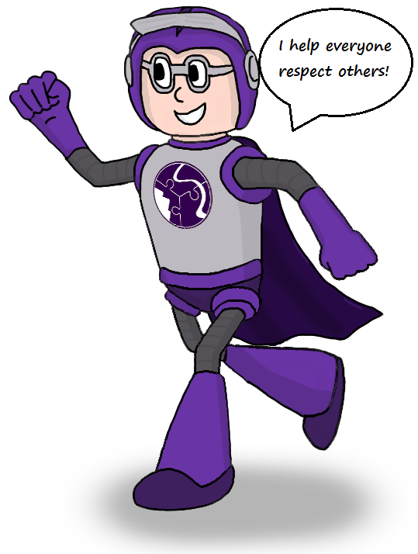

Strathesk Primary School


Learning & Development
2017-18

An insight into the life and work of Strathesk Primary School.

The Standards & Quality Report looks at developments and successes from last session whilst the School Improvement Plan outlines plans for this coming school year.

‘Learning together benefits all’

Standards & Quality Report
2016-17
Key learning & development:
- Achievement of Sport Scotland GOLD Award
- Enhanced Sports Day – with children in House Teams – great success in our second year of this re-vamp!
- P7 participation in residential camps and the John Muir Award
- P6 Benmore Camp – building resilience and capacity for our youngsters due to start P7
- ‘The Strathesk Learning Toolkit’ – successfully embedding our skills for learning through certificates and celebrations
- Ongoing positive relationships with our French Learning Assistant and great staff development with 3 Strathesk teachers visiting France through the Erasmus programme
- Improved opportunities in the teaching of Science through links with STEM and the Penicuik ASG Cluster project
- Mr Armstrong and the choir presented another fabulous music concert
- Inspiring Classrooms – Primary 7 enhanced their learning environment with new approaches, state of the art resources and furniture
- The Mayberry Mystery – Scientific investigation and critical thinking from Primary 7 pupils who attempt to solve a murder mystery!
- PEEP ‘2’s’ group up and running and more PEEP training opportunities for our nursery staff
- ‘Talk for Writing’ in the Early Years saw a huge improvement in Listening & Talking skills and promoted rich material and a readiness to write!
- Continued effective work in school to maintain The BIG Award status (Bullying Intervention Group)
- Successful multi-agency working to support children and families

Strathesk Primary School is part of the
‘Penicuik Associated Schools Group’ (ASG)
Head Teachers and Senior Managers join together to discuss common priorities, leading staff in working collaboratively towards school improvement. Last session the Penicuik ASG took part in joint working on:
- Moderation of Literacy & Numeracy
- Transition camp
- Science
- Visible Learning

ASG focus areas for session 17-18
- Penicuik and Beeslack ASG schools working together to achieve common goals
- Moderation of Literacy & Numeracy
- Science – continued development of learning and teaching and staff development in Science
- ‘Visible Learning’ – continuing to develop our school plans and sharing these across the cluster

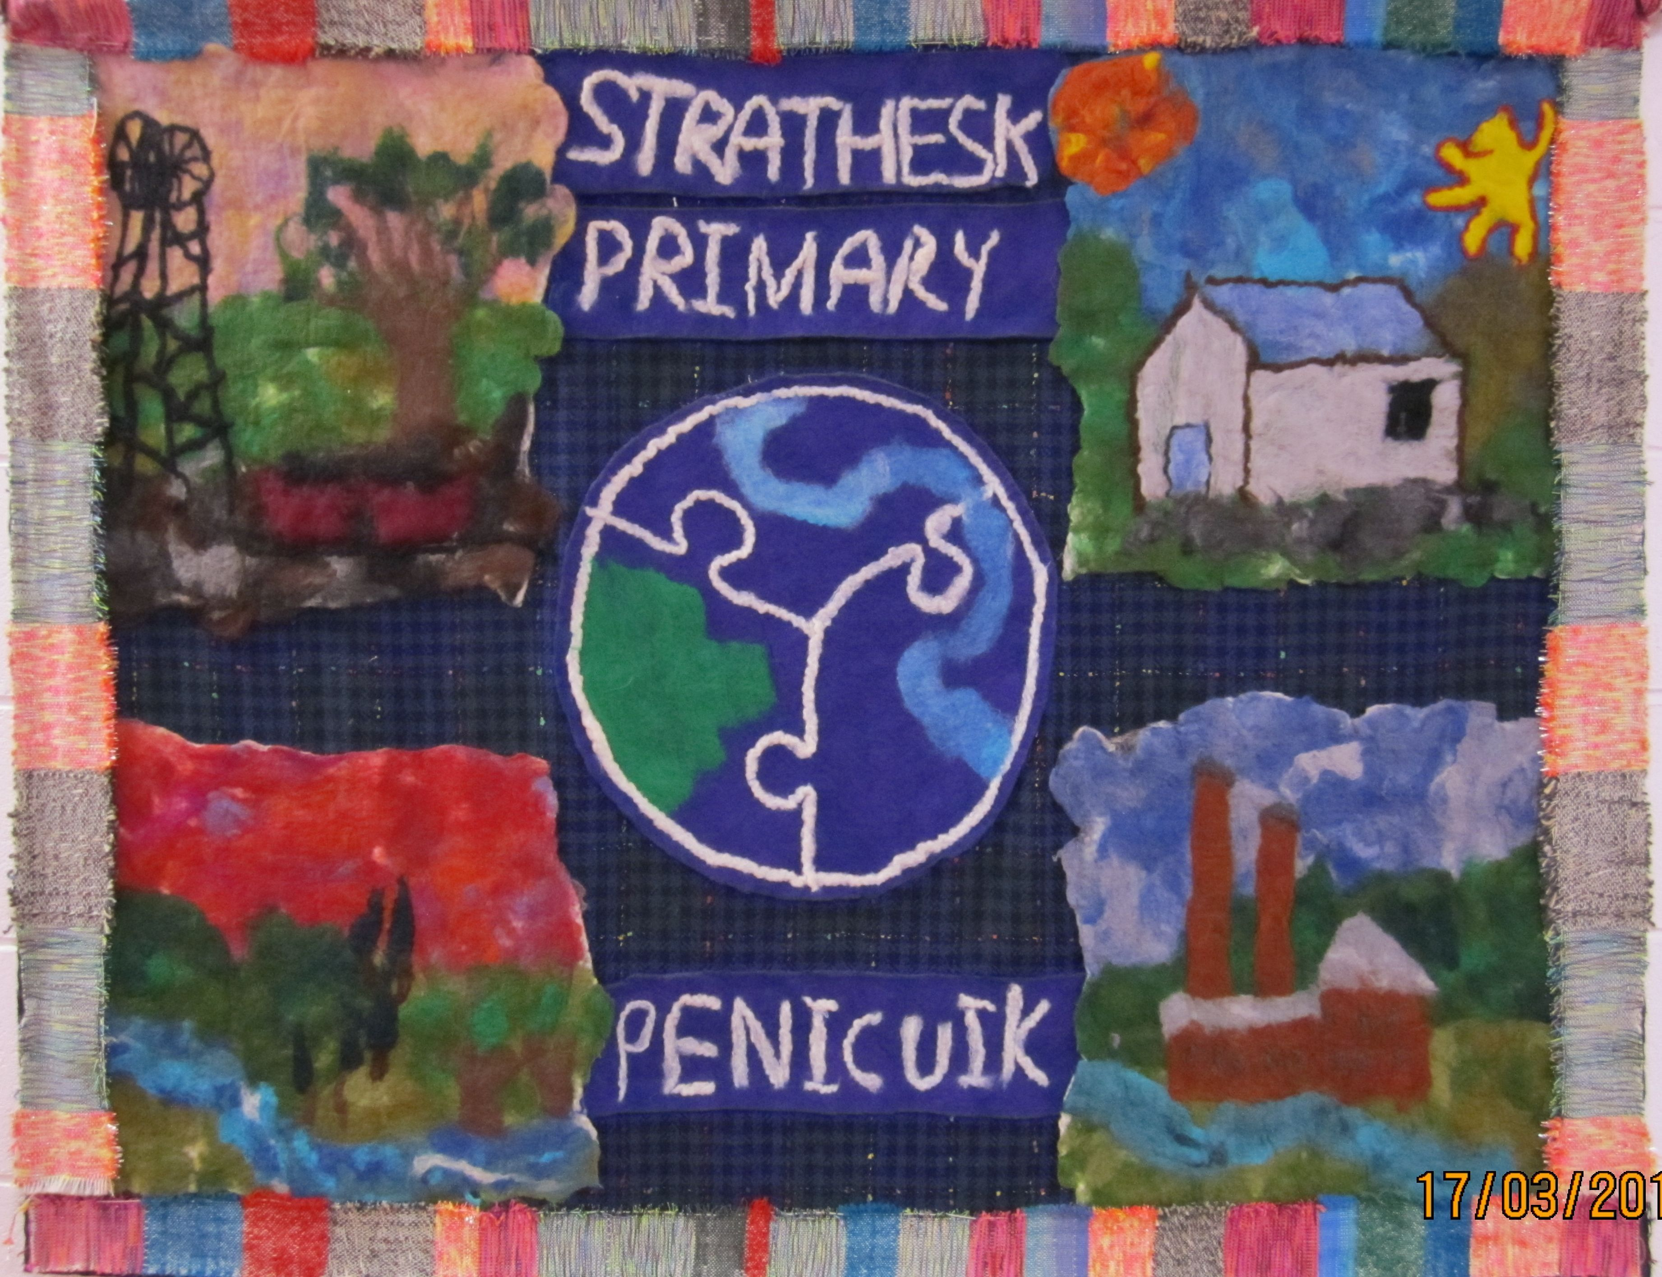

School Improvement Plan 2017-18

We are continuously developing the whole school and the curriculum and this session we are working on certain priorities to develop learning and improve attainment and achievement.
Improved attainment in Numeracy & Literacy
- On-going focused Numeracy and Literacy planning and moderation
- Further embed the use of Learning Journeys in Numeracy and Maths
- ‘Talk for Writing in the Early Years’ – Further development of this innovative literacy project – linked to the ‘Learning Through Play’ agenda
Improved Health & Wellbeing
- Revisiting our Positive Behaviour Guidelines
- Pupil Equity – Interrupting the Cycle of Poverty
Various in-school teaching and therapeutic supports designed to promote equity in attainment
Additional Curricular/General Items
- The development of play-based learning in the Early Years – promoting readiness to learn in all areas
- Developing Learner Profiles to support learner dialogue and the sharing of learning with parents
- Developing the role of the Pupil Council and the Parent Partnership
- Improved engagement with families and the local community
- New National Tests for Primary 1,4 & 7 – due to start March 2018
- Enhancement of the school website
- Whole school Interdisciplinary Learning Project led by Purpleman himself!

