In cases where the child’s behaviour has not settled and is continuing to disrupt learning, management will be asked to intervene. A purple slip will be sent home to inform you of the incident.

If the behaviour is consistent and/or of a serious nature we will ask you to come in and together will consider a consequence or a future action plan.

If you would like to discuss our Ready to Learn programme in more detail please feel free to contact your child’s class teacher or a member of the Senior Leadership Team.

**Kindness does not mean giving students what they want, it means giving them what they need.’**

**Paul Dix**





**At Strathesk Primary School**



**Learning Together Benefits All**

We are passionate about developing good relationships between children and staff at Strathesk Primary School.

We believe that better relationships do lead to better learning.

At Strathesk we aim to provide a happy, warm and safe environment for our children and in doing so encourage them to follow our school rules:

**Respect ourselves**

**Respect others**

**Respect property**

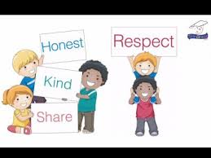

**What happens if my child does not follow the school rules?**

We believe in giving children the tools to self-regulate and change their behaviour. We discuss what good behaviour looks like and strategies the children can use to stay on task and be ready to learn.

If a child is off task we will give a:

Reminder

This will be done in private where possible. Are they ready, respectful and safe?

Caution

We will use this term as their final warning to change their behaviour.

Moved

The child will be moved to another space in the classroom, away from distractions.

Time Out

The child will be given time to reflect on their behaviour, space to calm down, before returning focussed and ready to learn.

Restorative

Pupils are listened to and supported to reflect on the incident. They are given guidance to plan to prevent incidents occurring again.



**.**