Literacy | Numeracy | Health and Wellbeing
Mark Making - Writing Trays  Fill a tray with either salt, sugar, flour or even shaving foam for some extra messy fun. Show your child some letters from their name or a variety of shapes for them to copy in the tray with their finger. | Snowman Skittles  Using toilet paper tubes or empty bottles, decorate to make 10 snowman skittles. Knock the skittles down with a ball and count how many have fallen each time. | DIY Fake Snow  Using only 2 ingredients you can make a dough that looks like fake snow. Mix 1 cup of hair conditioner or shaving foam with 1 cup of baking soda.
Snowman Names  Cut out some circles from white paper and on each circle write a letter of your child’s name. Make a snowman’s face on a separate circle, with a Hat and scarf. Help your child to construct the snowman while making their name. | Snowman Numbers  On the back of the lettered circles, write numbers. Ask your child to construct a snowman with 1 circle, 2 circles, 3 circles, etc. | Make Bird Feeders  Loop some cereal like cheerios on to a pipe cleaner. or a straw and tie off in a circle. Hang on the trees in your garden so the birds have some food to eat.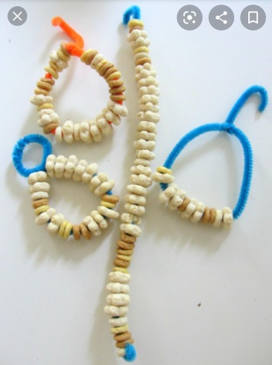

Songs

5 Little Snowmen
“5 little snowmen on a snowy day,
The first one said ‘lets play, what do you say’,
The second one said ‘lets stomp on the ground’,
The third one said ‘lets roll on the ground’
The fourth one said ‘lets run and run and run’,
The fifth one said ‘I’m afraid i see the sun’,
And the 5 little snowmen waved a fond goodbye”

I’m a Little Snowman
“I’m a little snowman short and fat,
Here’s my buttons, here’s my hat,
When the sun comes out i can’t play,
I just slowly melt away”

