Home Learning Grid WB 18.01.21
You will find all resources for the following tasks in the Classwork tab. Although we would love everyone to engage fully with Google Classroom activities, please do what works for you as a family. The suggested days for literacy and numeracy tasks (and any ‘deadlines’ that appear on assignments) are only guides to help you manage your child’s work.

 | Monday | Tuesday | Wednesday | Thursday | Friday
Literacy | Phonics  Watch the daily Read, Write Inc. speed sound lesson for today.  https://www.ruthmiskin.com/en/find-out-more/parents/  Reading  Find out what book you have been given to read this week on Oxford Owl. Follow the login instructions and reading guidance on Google classroom.  Handwriting  Log on to ‘letter-join’ and try the tasks set for you this week.  https://www.letterjoin.co.uk/  Username: eg06455  Password: home | Phonics  Watch the daily Read, Write Inc. speed sound lesson for today.  Reading  Follow the login instructions and reading guidance on Google classroom.  Writing  Choose one of the ‘Talk for Writing’ story booklets posted on Google classroom.  Spelling  Try some fun ways to practice your common words! Write out your words in rainbow colours, forwards then backwards or using fancy letters. Common word lists have been posted on Google classroom. | Phonics  Watch the daily Read, Write Inc. speed sound lesson for day.  Reading  Follow the login instructions and reading guidance on Google classroom.  Writing  Read or listen to the Talk for Writing story again from yesterday and have a go at another 1-2 of the activities in the booklet.  Handwriting  Log on to ‘letter-join’ and try the tasks set for you this week. | Phonics  Watch the daily Read, Write Inc. speed sound lesson for today.  Reading  Read your eBook to someone at home or to your favourite toy.  Spelling  Try some fun ways to practice your common words! Write out your words in rainbow colours, forwards then backwards or using fancy letters. Common word lists have been posted on Google classroom.  Handwriting  Log on to ‘letter-join’ and try the tasks set for you this week. | Phonics  Watch the daily Read, Write Inc. speed sound lesson for today.  Reading  Complete 1-2 of the reading follow up tasks below:  1. Choose a favourite sentence from your book to read, write and draw. Remember to use a capital letter, finger spaces and a full stop!  2. Complete a book review.  3. Read, write and draw 6 words from your book. Write the word before drawing them!  4. Find a word in your book for each letter of the alphabet.  Follow up sheets have been posted on Google classroom.
Numeracy | Numeracy & Maths  Money - Counting  Watch the Bitesize clip ‘Decimal System Coinage’  https://www.bbc.co.uk/bitesize/clips/zd4xn39  Complete the ‘Make the Total’ sheet.  Choose your own challenge: 1 star to 3 stars. Answers are at the end.  Extra Challenge: Try the ‘Using Pounds and Pence’ sheet  Mathletics: The ‘Money’ has been set.  P2 Mathseeds: Log on and try the ‘Money’ assignment. | Numeracy  Multiplication - Repeat Addition  Watch the Bitesize clip ‘How can adding help you multiply?’  https://www.bbc.co.uk/bitesize/topics/znj7hyc/articles/znbwhbk  Print the worksheet or just write the answers:  P3 Revision of x 2 sheet  Mathletics: Look the ‘Patterns and Relationships’ activities that have been set. Some of P3 have completed these already.  Hit the Button.  P3: Times Tables and Division. Revise 2, 5 and 10  https://www.topmarks.co.uk/maths-games/hit-the-button | Numeracy  Multiplication - Using an Array  Watch the Bitesize clip ‘How can using an array help me multiply?’  https://www.bbc.co.uk/bitesize/topics/znj7hyc/articles/z7prqp3  Print the worksheet or just write the answers:  P3 Revision of x 5 sheet  Mathletics: Look the ‘Patterns and Relationships’ activities that have been set. Some of P3 have completed these already.  Hit the Button.  P3: Times Tables and Division. Revise 2, 5 and 10  https://www.topmarks.co.uk/maths-games/hit-the-button | Maths/Numeracy  Money - Add and Subtract  Watch the Bitesize clip ‘Add and Subtract Coins’  https://www.bbc.co.uk/bitesize/clips/zw3jxnb  Complete the ‘Spider Mental Money Addition’ sheet.  Choose your own challenge: 1 star to 3 stars. Answers are at the end.  Mathletics: The ‘Money - Adding’ activity has been set.  P2 Mathseeds: Log on and try the ‘Grouping’ assignment. | Numeracy  ‘Convince Me’ Card Friday  Use the set of P2 cards as core questions. You do not need to print them. Just talk about the answers. There are 4 cards.  P3 cards can be done next (by P2 as well) to give more challenge.  Is Tom’s Thinking correct?

Other Tasks for this Week
PE  PE with Joe Wicks 2021  PE with Joe videos will be streamed live on YouTube on Mondays, Wednesdays and Fridays at 9am from Monday 11th January.  streamed live on Wicks’ YouTube channel  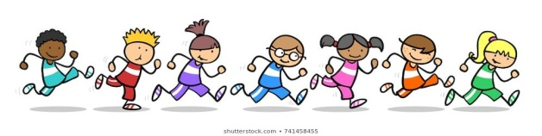  Health & Wellbeing  Hand Washing Heroes!  Hand washing is one of the best ways to keep us from getting sick and prevent the spread of germs.  Read the story about ‘Super Soap’ and make your own super soap bottle hero. You could always design your own hand washing superhero!  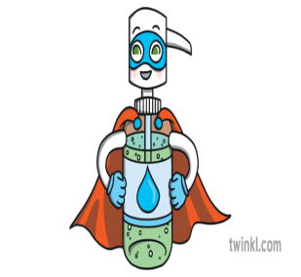  Try the germ experiment below.  https://www.bbc.co.uk/cbeebies/watch/germs-experiment | French  Lingo Box Learning on YouTube  Numbers 1 - 31!  Get active and learn French numbers. Stop at number 10 or challenge yourself up to 31!  https://www.youtube.com/watch?v=9aYMV4jkVgA  Expressive Arts  Music  Try the home learning task from Mrs McInroy on Google classroom. Have fun!  Art ‘Thistle Picture’  The thistle is the national emblem of Scotland. Legend has it that a group of Vikings were sneaking up on some Scotsmen who were resting nearby. One of the Vikings stepped in a thistle patch with bare feet and his cries alerted the Scots warriors to the danger they were in, saving them from attack!  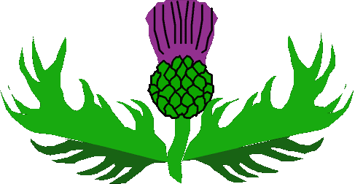  Have a go at drawing a thistle. A step to step video has been posted on Google classroom. | Topic ‘Scotland’  We will start by looking at the geography of Scotland. If you have a map or a globe at home try to find Scotland. Look closer- what cities can you see?  Look at the PowerPoint.  Fill the city names in on the sheet attached.  What famous landmarks are there in Scotland?  Look at the Landmark PowerPoint.  Find the landmarks on the attached sheet and fill in some of your own if you can.  P3 - This would be a wonderful topic to make a PowerPoint for.  1/ Title Page - SCOTLAND  2/ Map  3/ Landmarks (more than one page) - add photos.  More to be added in the next few weeks!  